Predictive Modeling Using Machine Learning
Task: Predicting Titanic passenger survival (binary classification)

1. Objective
Building on the cleaned Titanic dataset from the Data Cleaning & Visualization project, this project trains and compares three classification models to predict whether a passenger survived. Because the target is binary (survived / did not survive), Logistic Regression is used as the linear model — the classification counterpart of Linear Regression — alongside a Decision Tree and a Random Forest.

2. Data & Features
- Source: titanic_cleaned.csv (output of Project 1 — 784 rows, already deduplicated, imputed, and outlier-capped).
- Features used: passenger class, age, siblings/spouses aboard, parents/children aboard, capped fare, sex, and port of embarkation (one-hot encoded).
- Target: survived (0 = died, 1 = survived).
- Split: 75% train / 25% test, stratified by survival to preserve class balance.
- Feature scaling (StandardScaler) applied for Logistic Regression; tree-based models used raw features.

3. Models Trained
- Logistic Regression — linear decision boundary, fast and interpretable baseline.
- Decision Tree Classifier (max depth 5) — captures non-linear interactions, easy to visualize.
- Random Forest Classifier (300 trees, max depth 6) — ensemble of trees, typically more robust and accurate.

4. Model Performance
Model | Accuracy | Precision | Recall | F1 Score
Logistic Regression | 0.811 | 0.768 | 0.778 | 0.773
Decision Tree | 0.806 | 0.795 | 0.716 | 0.753
Random Forest | 0.827 | 0.831 | 0.728 | 0.776

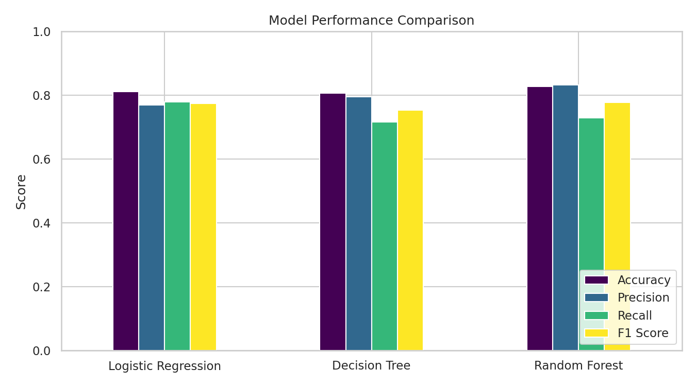
Figure 1 — Accuracy, precision, recall, and F1 score across the three models

5. Confusion Matrices
Confusion matrices show where each model's predictions land relative to the true outcome. All three models are noticeably better at correctly identifying passengers who died than those who survived, reflecting the class imbalance (more passengers died than survived) and the inherent unpredictability of individual survival.
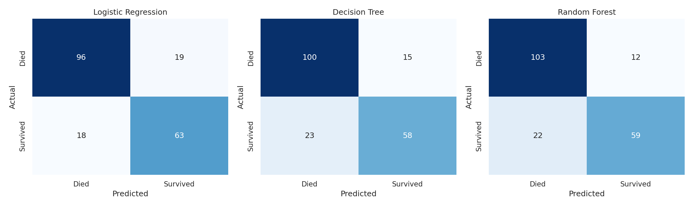
Figure 2 — Confusion matrices for Logistic Regression, Decision Tree, and Random Forest

6. ROC Curves
ROC curves plot the true positive rate against the false positive rate at every classification threshold. Logistic Regression and Random Forest both achieve strong separation (AUC ≈ 0.89), meaningfully outperforming the Decision Tree (AUC ≈ 0.82), which tends to overfit to specific splits.
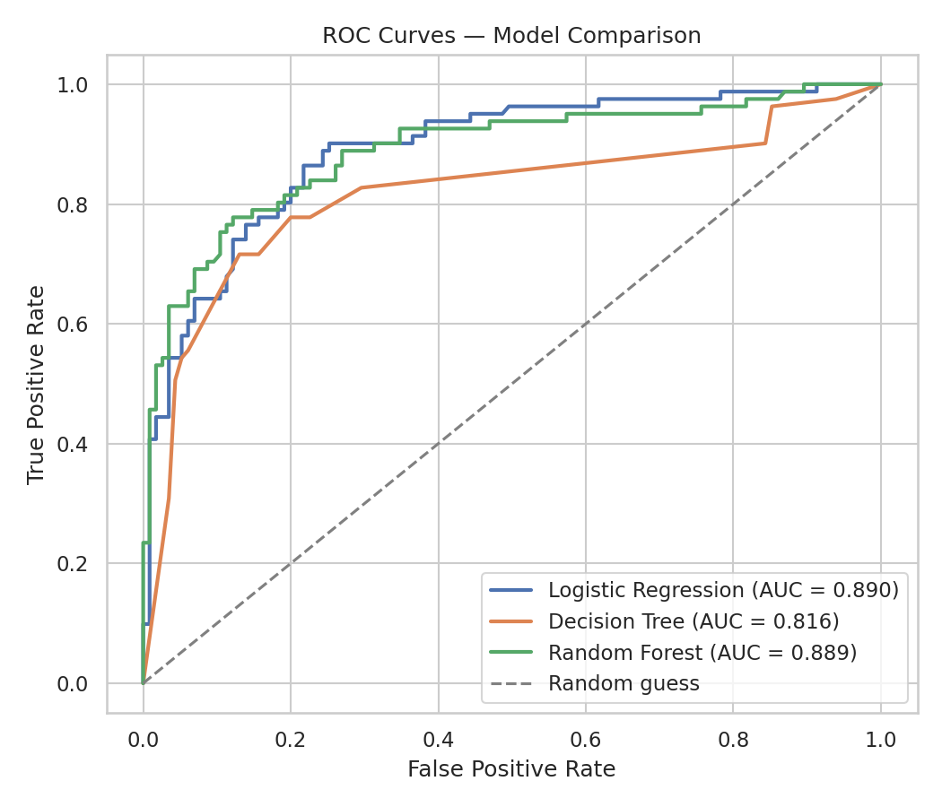
Figure 3 — ROC curves and AUC scores for all three models

7. Feature Importance
Using the Random Forest's built-in importance scores, sex (specifically, being male) is by far the strongest predictor of survival, followed by fare (a proxy for wealth/class) and age — consistent with the exploratory findings from Project 1.
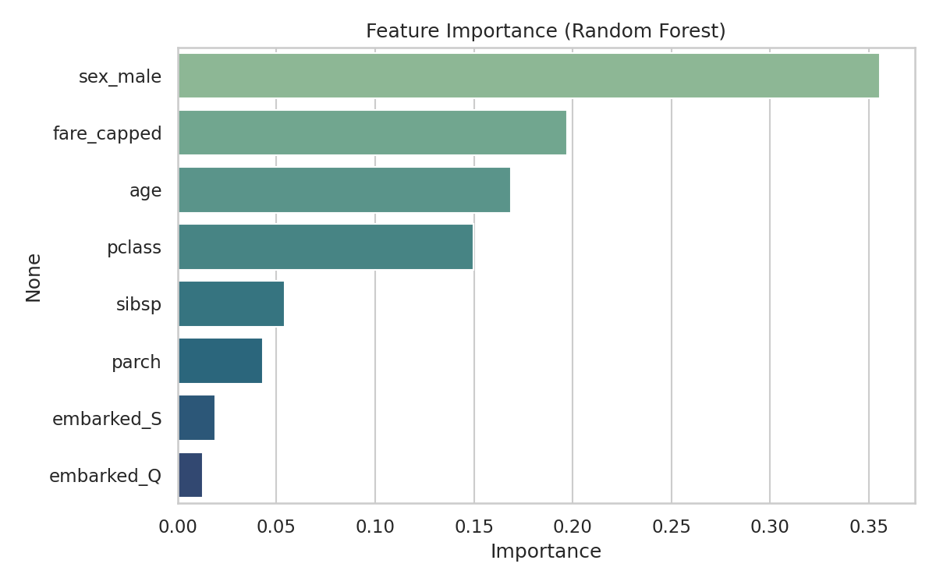
Figure 4 — Feature importance from the Random Forest model

8. Conclusion
The Random Forest model delivered the best overall balance of accuracy (82.7%) and F1 score (0.776), and tied Logistic Regression for the highest ROC AUC (0.89). Logistic Regression remains a strong, highly interpretable baseline, while the single Decision Tree underperformed both ensembles slightly due to overfitting on a modest dataset. For a production use case, the Random Forest is the recommended model, with Logistic Regression as a transparent fallback when interpretability matters more than a small accuracy gain.
Deliverables accompanying this report: the full Python modeling script (predictive_modeling.py), the model comparison table (model_comparison.csv), and an interactive HTML dashboard summarizing all performance metrics and charts.

